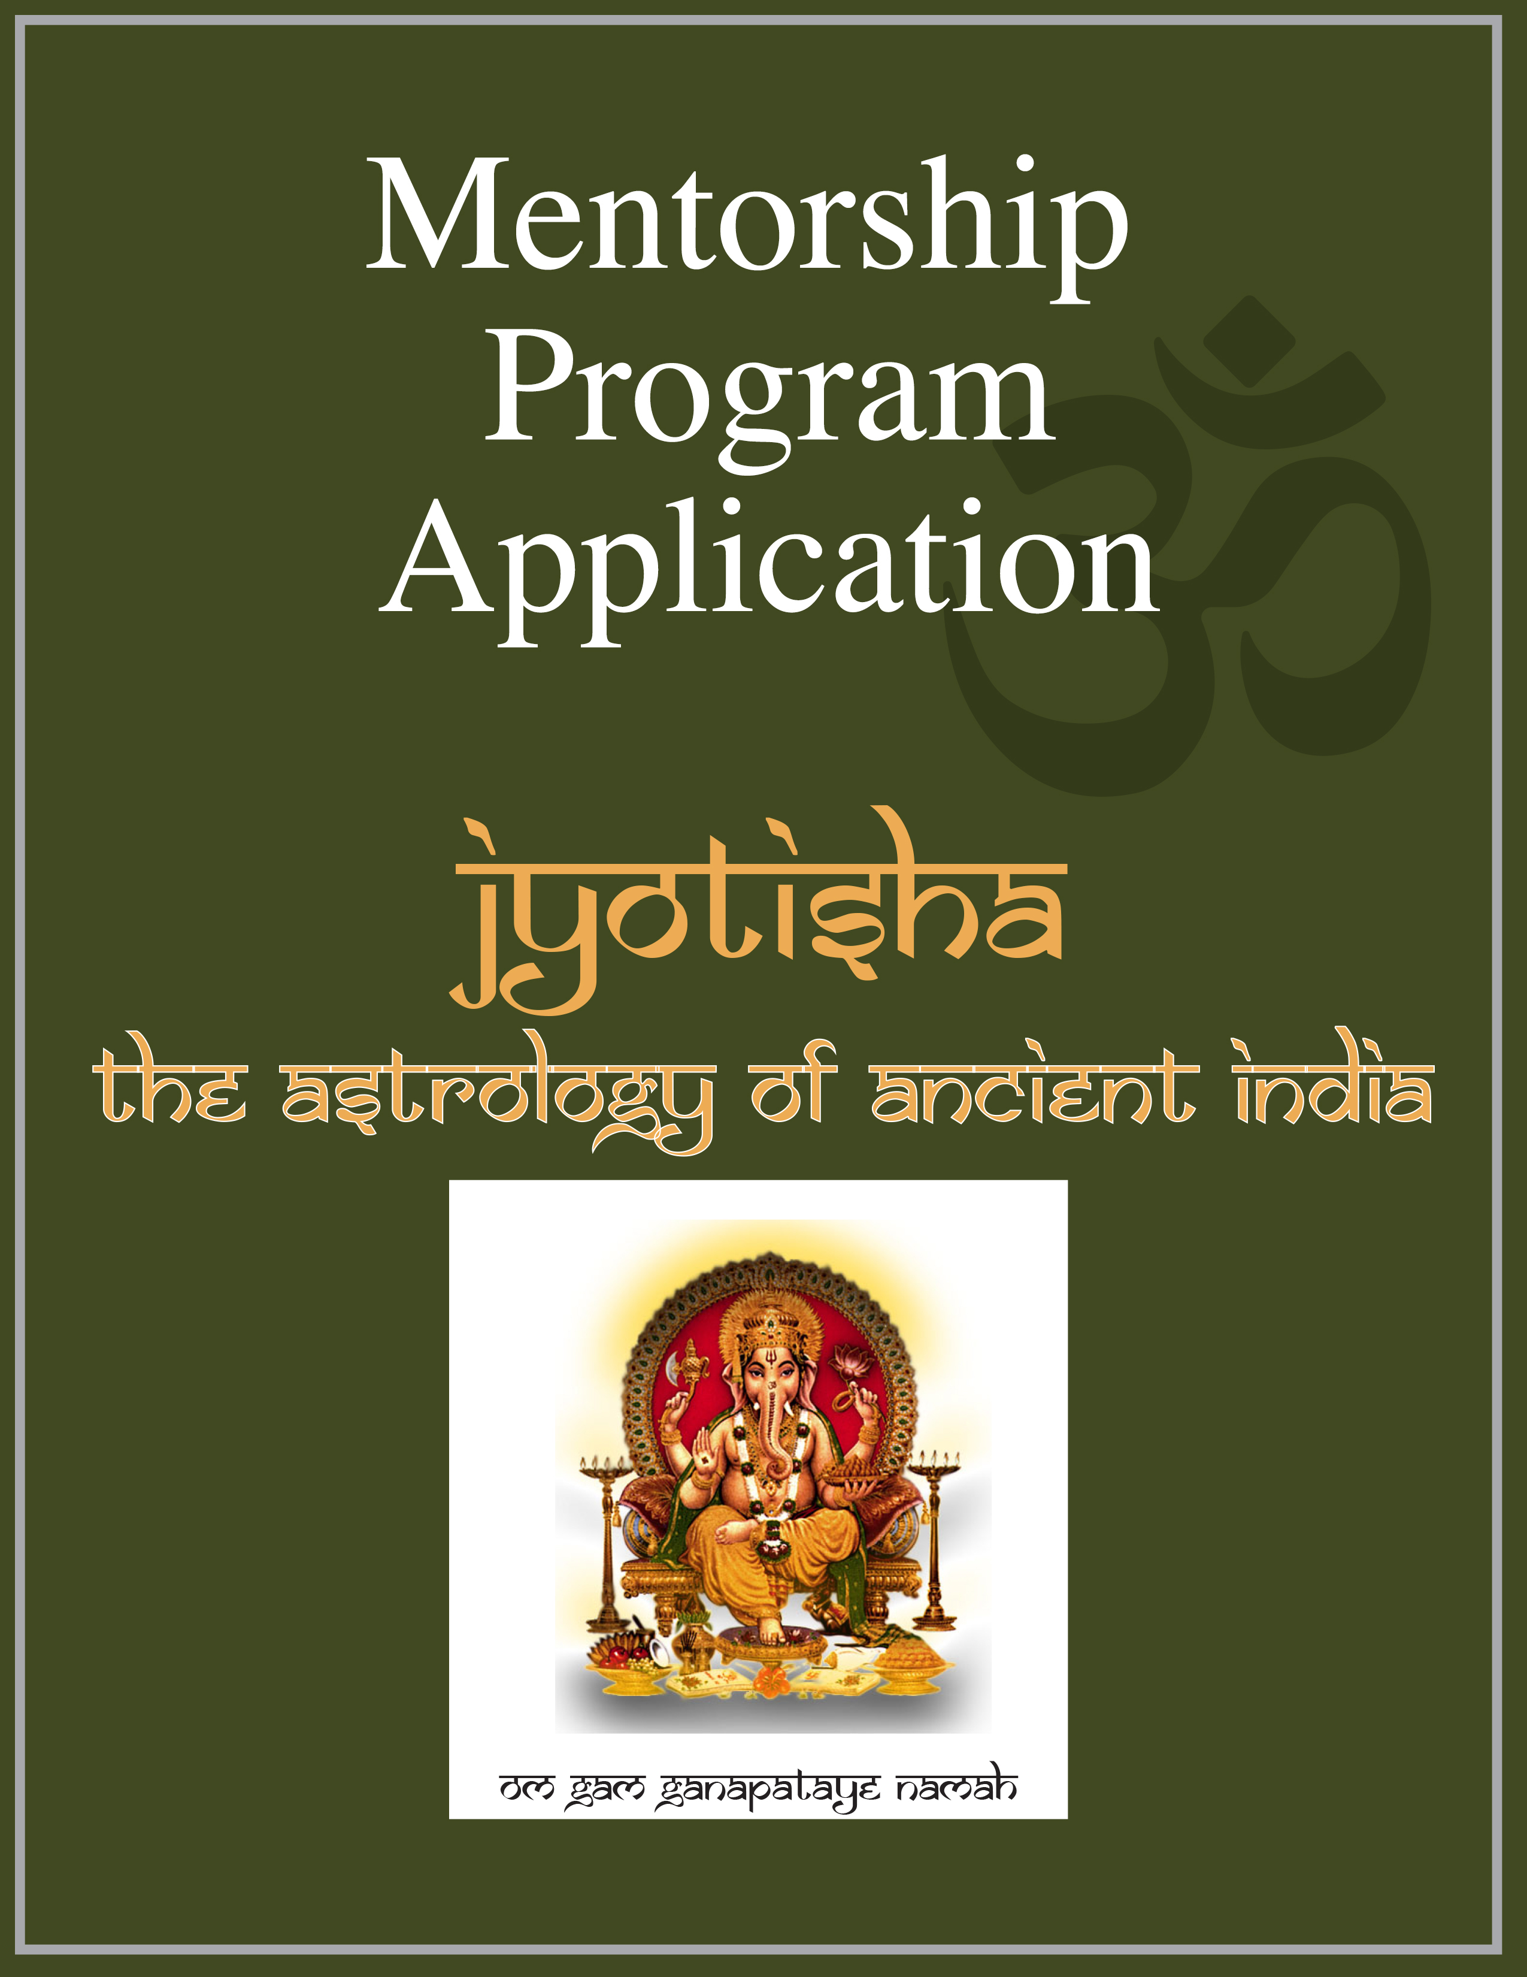
www.marcboney.com
Jyotisha Mentorship Program Application

Namaste!

I appreciate your interest in this individual learning opportunity. As a first step in the process, please complete the following form and submit it to marcboney@aol.com.

Students at all levels are welcome to apply, regardless of their prior background with Jyotisha. However, only a limited number of applicants will be accepted and on a select basis. Preference is for applicants with the following profile, though these qualifications should not be consider absolute prerequisites.

- College and/or advanced degree (demonstrates intellectual/learning capacity)
- On a spiritual path and engaged in regular spiritual practice
- Birth chart that shows a good capacity for Jyotisha
- Willing and able to devote time weekly to their study of Jyotisha.
- Willing and able to make a minimum three month commitment to the program
- Good oral and written communication skills

Applying to this program does not commit you to anything initially, and any information shared will be held in strict confidence.

Personal Information

Name:

Gender:

Birth Date:

Birth Time:

Source of Birth Time:

Birth Place:

Current Location/Time Zone:

E-mail Address:

Telephone Number:

Skype Address:

Questionnaire

In responding to the following questions, please feel free to give as much input as you would like.

- Please describe your background with Jyotisha and with astrology in general.

- Would you consider yourself a beginning, intermediate, or advanced student and why?

- What aspects of Jyotisha most interest you?

- What is motivating your interest in this program and what would you most like to get out of it?

- Do you have the goal of doing astrology professionally, either teaching, researching, writing, or consulting?

- Please describe your educational background and qualifications.

- Do you have a particular spiritual path that you have been on? If so, please describe?

- Is there anything else that you would like to share with me related to your interest and potential participation in this program?

